Assignment no. 4

1) Write a select command that produces the order number, amount and date for all rows in the orders table.

Ans-

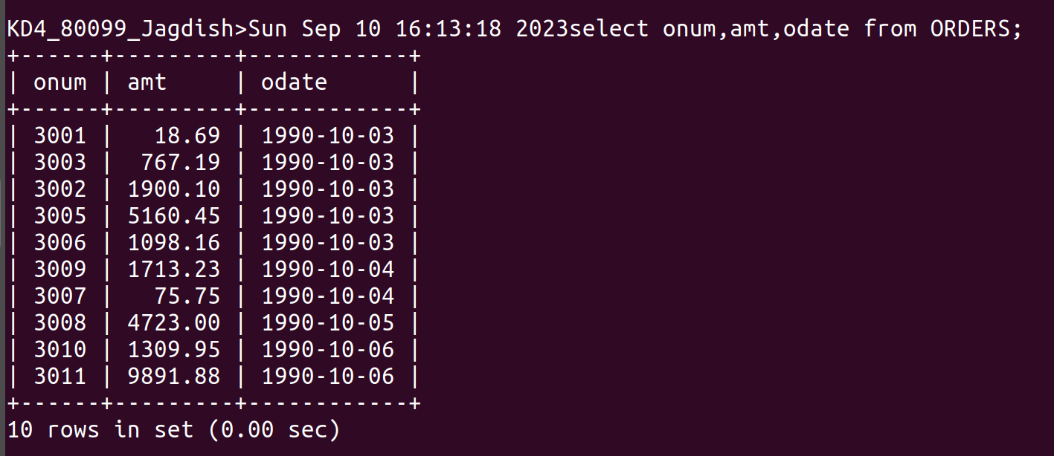
2) Write a query that produces all rows from the customers table for which the salesperson’s number is 1001.

Ans-

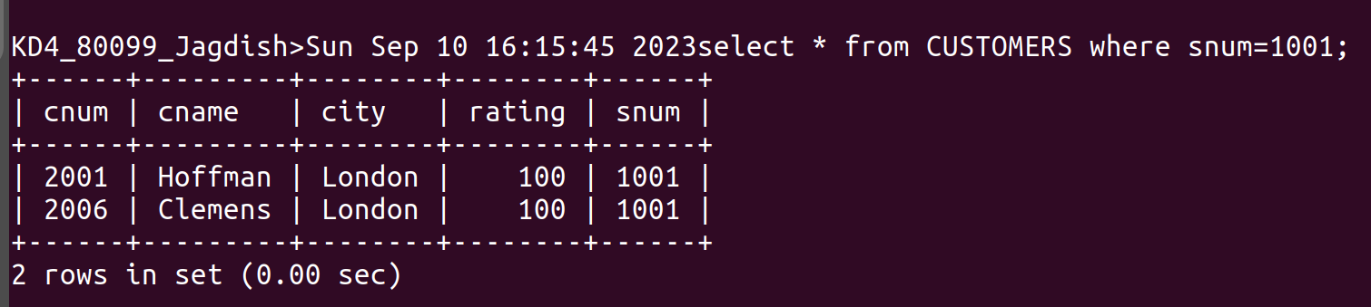

3) Write a query that displyas the salespeople table with the columns in the following order: city, sname,snum,comm.

Ans-

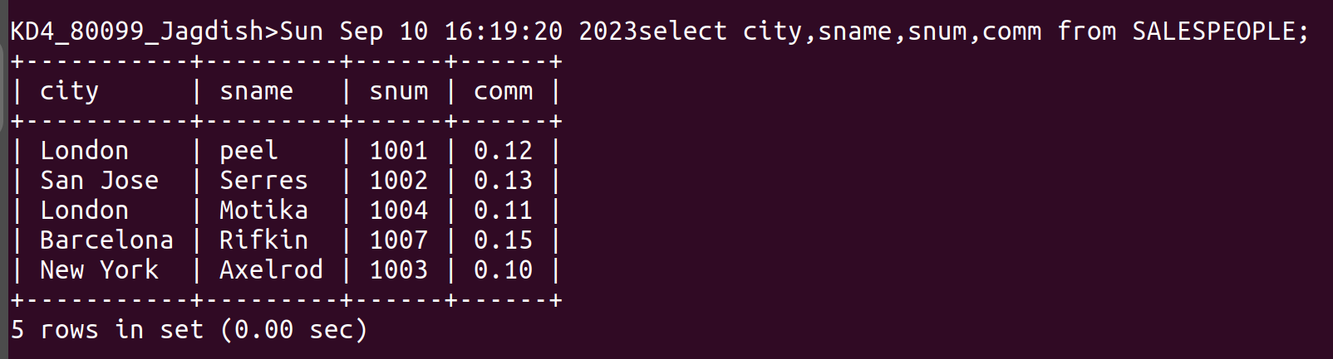
4) Write a select command that produces the rating followed by the name of each customernin San Jose.

Ans-

